Part 6 Fixed IP ADSL Network Component Settings
(for Win XP)
Once your network adapter is installed, you have to set your network component settings before you can go online and make use of high-speed ADSL. If you applied for fixed IP ADSL, please look at the network component settings steps below (fixed IP ADSL does not require PPPoE installation). To take users of different systems into account, we have provided separate network component settings explanations for Windows 98, Windows ME, Windows NT, Windows 2000 and Windows XP.

- Windows XP English Version – Fixed IP ADSL Connection Settings

1. Click on the [Start] button at the bottom left corner of your desktop with your left mouse button. When the Start menu appears, select [Connect To] and then [Show all connections]. | 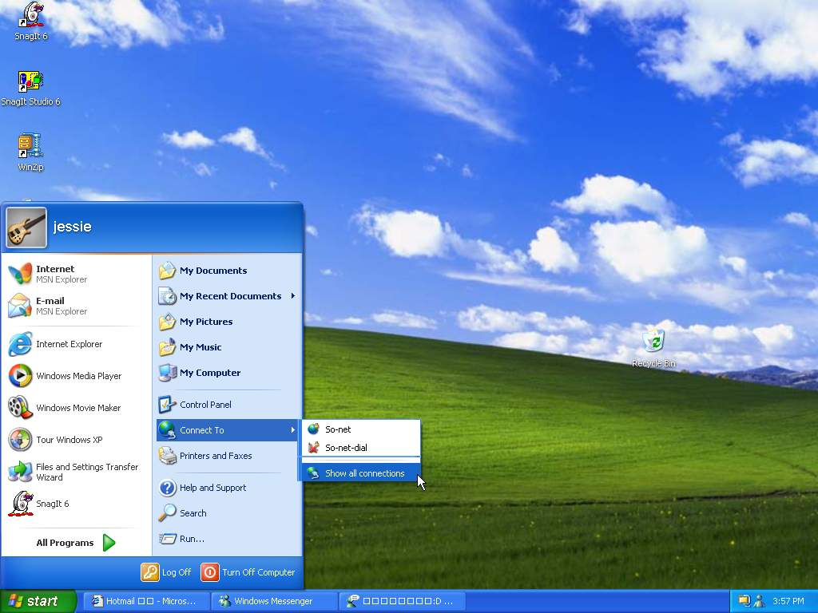
2. In the [Network Connections] window, right-click your [Local Area Connection] and select [Properties]. | 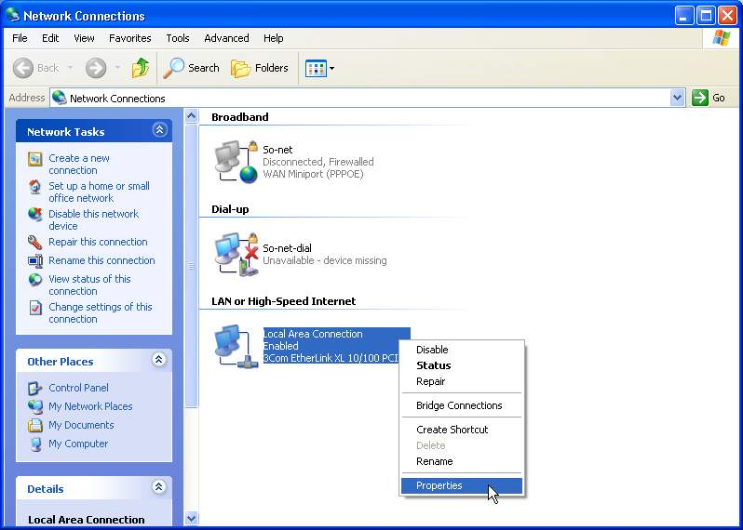
3. In the [Local Area Connection Properties] window, select [Internet Protocol (TCP/IP)] then click [Properties]. | 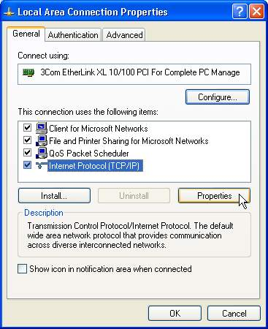
4. In the [TCP/IP Properties] window, select [Use the following IP address] and enter the [IP Address], [Subnet mask] and [Default gateway]. For these figures, refer to the documentation supplied by So-net. Then select [Use the following DNS server address] and enter the [Preferred DNS server] number (again, refer to the documentation supplied by So-net). When complete, click [OK]. | 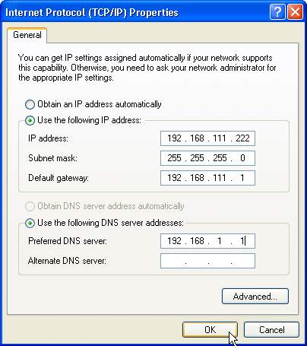
5. When the TCP/IP settings are complete, click [Close]. | 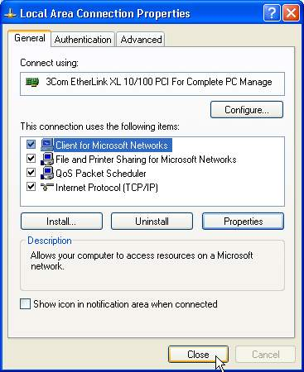
6. Return to the [Network connect ions] window. For the new settings to become active you must first disable and then restart your local connection. Right-click your [Local area connection] icon and select [Disable]. | 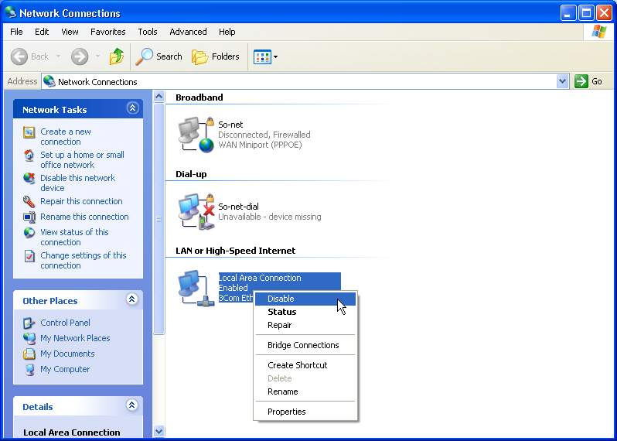
7. Select your [Local area connection] icon again and right-click. Select [Enable]. When this starts functioning, the fixed ADSL broadband Internet setup will be complete. | 